### PORTFOLIO/PROJECTS

* **ECOMMERCE WEBSITE:**
* Ecommerce Website designed in a planned structure using Html ,Css and Javascript.

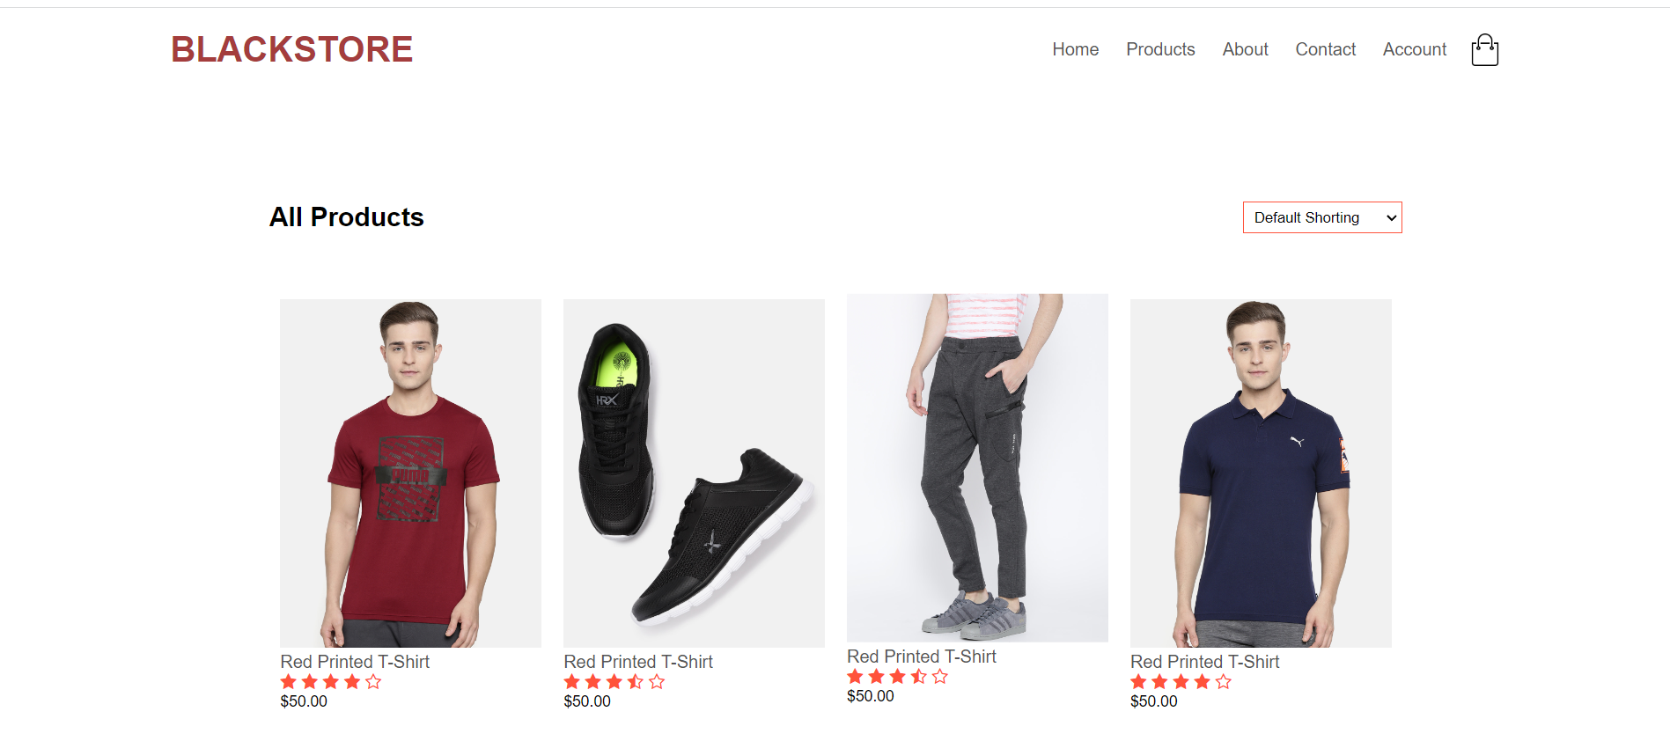

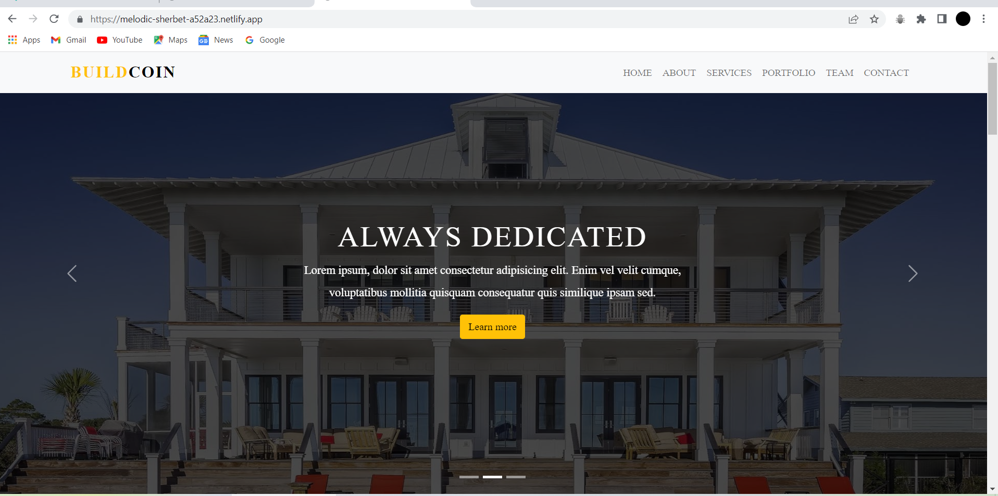

* **HOUSESELLING WEBSITE:**
* House selling website designed using html,css,bootstarp and Javascript.

### SKILLS:

* HTML
* CSS
* JAVASCRIPT
* REACT.JS
* BOOTSTRAP
* NODE.JS
* SQL
* PYTHON
* JAVA

### Education:

**Bachelor of Technology:**

Jawaharlal Nehru Technological University Hyderabad,India.(2022)

### Certificate:

* Simplilearn certification as front End Development.

(2021 may - 2022 jun)

**As a front End Developer to plan and design the structure and design of web pages**. To develop website features that can enhance the user experience. To strategize design choices according to user experience. To implement design for mobile sites.

MANI VARDHAN

Website: https://manivardhan12356.github.io/portfoliomani.io/

📞 +919553979185 📧 [manivardhan12356@gmail.com](mailto:manivardhan12356@gmail.com)